BORNEO AKADEMIKA (BA)

Volume X (X), Disember 2023 (…)

ISSN: 2462-1641
e-ISSN: 2735-2250

Journal home page:
https://borneoakademika.uitm.edu.my

INSTRUCTIONS FOR TYPESETTING MANUSCRIPTS USING MSWORD (TITLE “Arial” Size 12)

(* If the Title is written in Bahasa Melayu, translate the Title in English and place it below the Malay version italicised)

FIRST¹, SECOND² & THIRD³ AUTHORS’ FULL NAMES
^{1, 2, 3}Affiliation
Corresponding Author e-mail

ABSTRACT (“Arial”, Size 11)
The abstract should summarise the context, content, and conclusions of the paper in less than 250 words. It should not contain any reference citations or displayed equations. Typeset the abstract in 11 pt Arial. Papers are allowed to be written in either English or Bahasa Melayu (Malay).

Keywords: Provide five key words. keyword1; keyword2; keyword3

(* If the manuscript is written in Bahasa Melayu, translate the Abstrak in English and place it below the Malay version)

Introduction ("Arial", size 11)
Authors are encouraged to have their contribution checked for grammar. British English should be used. Abbreviations are allowed but should be spelt out in full when first used. Integers ten and below are to be spelt out. Foreign language phrases should be italicised (e.g. Latin, French). The text is to be typeset in 11 pt Arial font single spacing including the list of references. Text should be prepared in A4 size (21 cm × 29.7 cm) area with margins of 3.81 cm on top, 3.50 at the bottom, and 3.17 cm on the left and the right sides. Header and footer should be set at 2.3 cm and 2.2 cm from the edge, respectively.

Sub-headings
Sub-headings should be typeset in boldface italic and capitalise the first letter of the first word only.

Equations
Equations should be numbered consecutively, especially those that are to be referred*, and they should start at the first tab stop (5mm inside), with the number set flush right and enclosed in parentheses as shown below. The equation numbers should be consecutive within the contribution.

(1)

Equations should be referred to in abbreviated form, e.g. from (1). In multiple-line equations, the number should be given on the last line.
Equations should be typed using MathType. Standard English letters like x are to appear as x (italicised) in the text if they are used as mathematical symbols. Punctuation marks are used at the end of equations as if they appeared directly in the text.
Definitions and Theorem Environments
Definitions, theorems, lemmas, corollaries etc. are set on a separate paragraph, with extra 1 line space above and below. They are to be numbered consecutively within the contribution.

Definition 1 Definitions are set on a separate paragraph, with extra 1 line space above and below. Definitions are not italicised but the defined term is.

Lemma 2 Lemmas are set on a separate paragraph, with extra 1 line space above and below. They are to be numbered consecutively within the contribution and are italicised

Theorem 3 Theorems are set on a separate paragraph, with extra 1 line space above and below. They are to be numbered consecutively within the contribution and are italicised

Proof. Proofs should end with ‘•’.

Illustrations and Photographs
The caption must be placed below the figure. Typeset caption in 9 pt Arial. Long captions are to be justified by the “page-width”'. Use double spacing between a caption and the text that follows immediately, e.g. Figure 1.
Previously published material must be accompanied by written permission from the author and publisher.
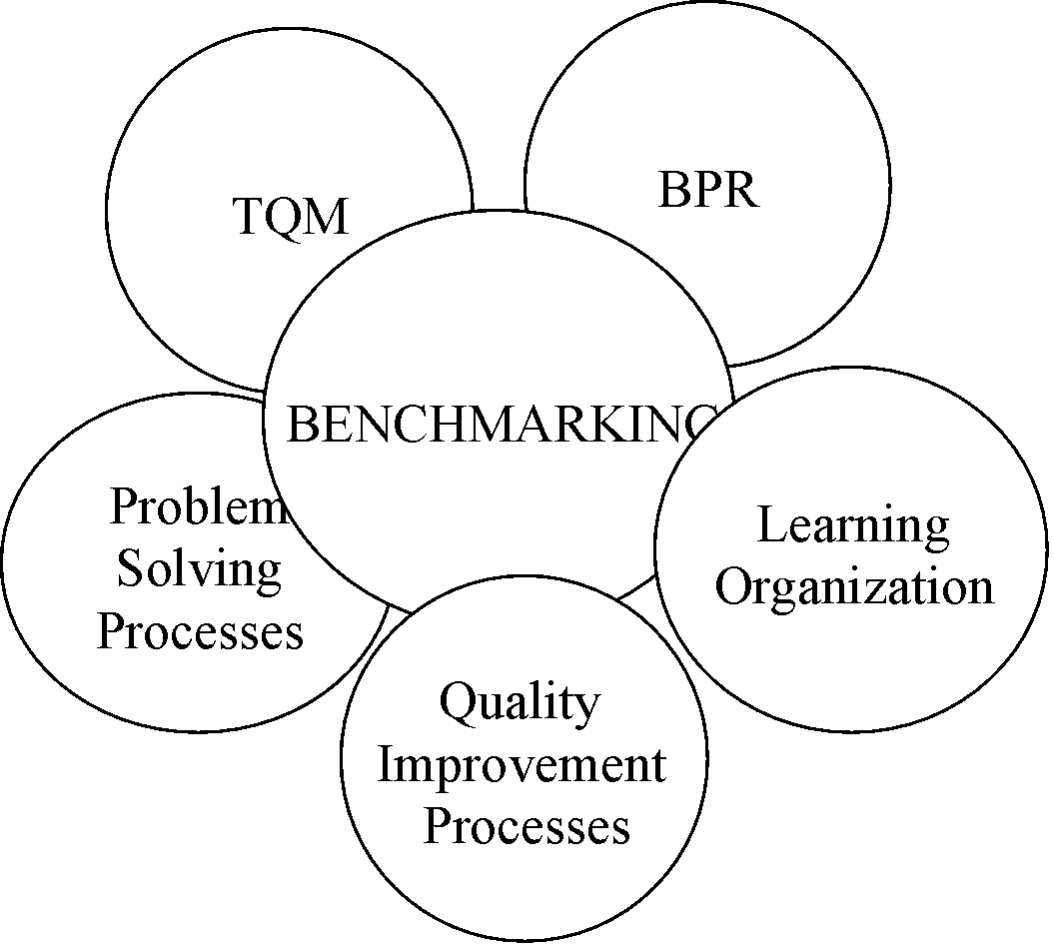

Figure 1: Benchmarking in relation to change programs (Codling, 1996; Cook, 1997
Tables
Use double spacing before and after the table and main text, e.g. Table 1.
Tables should be numbered sequentially in the text using Arabic numerals. Captions are to be centralised above the tables. Typeset tables and captions in 9 pt Arial. Long captions are to be justified by the “table-width”.

If tables need to extend over to a second page, the continuation of the table should be preceded by a caption, e.g., “Table 1 (Continued)”. Notes to tables are placed below the final row of the table and should be flush left. Footnotes in tables should be indicated by superscript lowercase letters and placed beneath the table.

Table 1: Measurement of the SEM model
 | Std.  Loadings | Standard  Errors | Critical Ratio | Probability
(i) Constructs and Indicators
a. TQM
Top management commitment | 0.416 | 0.097 | 8.153 | 0.000
Customer focus | 0.773 | 0.054 | 15.84 | 0.000
Benchmarking | 0.586 | 0.074 | 11.77 | 0.000
Training | 0.800 | 0.074 | 15.84 | 0.000
Employee focus | 0.805 | 0.058 | 16.39 | 0.000
b. Customer Satisfaction (CS)
Customer satisfaction on service quality (Cquality) | 0.743 | 0.053 | 16.466 | 0.000
Customer satisfaction on facilities provided (Cfcility) | 0.808 | 0.069 | 16.115 | 0.000
Customer satisfaction on service given by counter employees (Cemploy) | 0.901 | 0.058 | 17.759 | 0.000
(ii) Exogenous/endogenous Path
a. TQM→ CS | 0.222 | 0.074 | 3.835 | 0.000

Acknowledgments
This section should come before the References. Funding information may also be included here.

References (APA 7th Ed.)
Typeset reference list in 9 pt Arial with single spacing.

Lee, B., Rumrill, P., and Tansey, T. N. (2022, May 16). Examining the role of resilience and hope in grit in multiple sclerosis. Frontiers in Neurology, 13, Article 875133. https://doi.org/10.3389/fneur.2022.875133
Ruxton, C. (2016). Tea: Hydration and other health benefits. Primary Health Care, 26(8), 34-42. https://doi.org/10.7748/phc.2016.e1162

